MoSCoW – Library Management System
Aim:
To categorize requirements using MoSCoW method.
Procedure:
1. List all requirements.
2. Analyze impact & feasibility.
3. Categorize into:
- Must Have
- Should Have
- Could Have
- Won’t Have
4. Enter into Excel/Google Sheet.
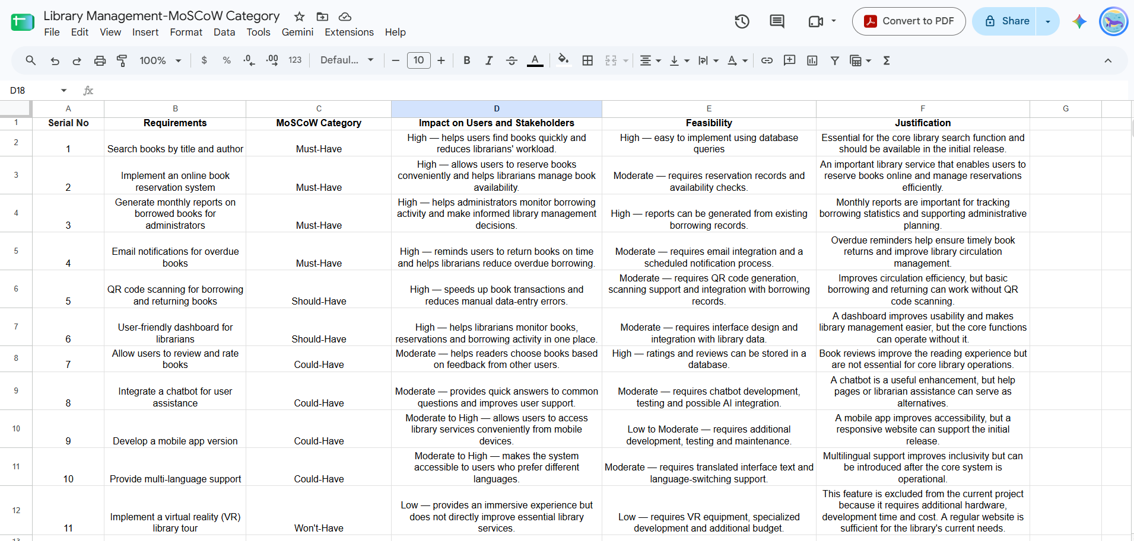
5. Add justification column

Result: Thus, The Requirements categorized successfully using MoSCoW prioritization

